**Beam Analysis. Beams on Axis 3, Axis 7**

**1. Sketch.**

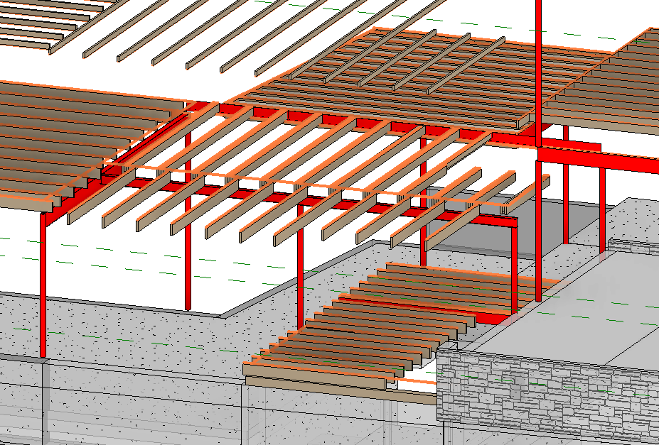

**2. Input Summary.**

2.1. Applicable codes.  
2.1.1. Wisconsin Administrative Code, Chapter SPS 321 – Uniform Dwelling Code  
2.1.2. ASCE 07-05, Minimum Loads on Buildings  
2.1.3. AISC 360-05, Specification for Structural Steel Buildings  
  
2.2. Design considerations.

As per 2.1.1, allowable stress design (ASD) is performed for steel elements using 2.1.3.

2.3. Load values

Dead Load Calculation:

Minimum value: Dmin = 10 psf;

Flooring: Wood Joists w/ Wood flooring D1 = approx. 12 psf;

Walls: light-frame wood walls D2 = approx 6 psf

Max D1+D2+D3 & Dmin **D = D1+D2 = 18 psf**

**D** = 18 psf as per WAC Chapter SPS 321, calculation  
**L** = 40 psf as per WAC Chapter SPS 321 Table 321.02

**3. Structural Design.**

3.1. Floor 2, Central Beam Design – Beam at grid (3).

3.1.1 Span 1

Initial material: A99 Steel ASTM.

Span = 12.5’

Length = 24.4’

Loads Calculation

Load Area = 12.5 x 12 = 150 sf.

Dead Load = 150 x 18 / 12.5 = 216 pf = 0.22 kip/ft

Live Load = 150 x 40 /12.5 = 480 pf = 0.48 kip/ft

AISC Check

ASD Design as per 2.1.1. SPS

Section = **W6X16**

Fy = 50 ksi

Fu = 65 ksi

All considered sections are compact, Y and LBW checks apply.

3.1.2 Span 2

Initial material: A99 Steel ASTM.

Span = 11.7’

Length = 24.4’

Loads Calculation

Load Area = 11.7 x 12 = 140.4 sf.

Dead Load = Wd = 140.4 x 18 / 11.7 = 216 pf = 0.22 kip/ft

Not a governing span – design as per 3.1.1. Calculations not required.

3.2.1 Floor 2, Lintel Beam Design – Beam at grid (4), uniform load + conc. load

Initial material: A36 Steel ASTM.

Span = 12’

Length = 24’

Loads Calculation

Span 1:

Load Area = 12 x 7.5 = 90 sf.

Dead Load = 90 x 18 / 12 = 135 pf = 0.135 kip/ft

Live Load = 90 x 40 /12 = 300 pf = 0.3 kip/ft

Span 2:

Load Area 1 = 7.4 x 7.5 = 55.5 sf

Load Area 2 (point) = 10.7 x 13 = 139 sf

Dead Load = 55.5 x 18 / 12 = 0.083 kip/ft

Live Load = 55.5 x 40 / 12 = 0.185 kip/ft

Point Dead Load = 139 x 18 = 2.5 kip

Point Live Load = 139 x 40 = 5.56 kip

AISC Check

ASD Design as per 2.1.1. SPS

Initial section = L6X4X9/16

Fy = 36 ksi

Fu = 58 ksi

Y, LBW, LLB checks apply.

**4. Design Results**

4.1.1 Floor 2, Central Beam Design – Beam at grid (3).

Unbraced: = A992 Steel, W Shape **W6X16** (see Calculation 3.1.1.)

4.2. Floor 2, Lintel Beam Design – Beam at grid (4).

Unbraced: = A36 Steel, L Shape **L6X4X7/8** (see Calculation 3.2.)

**Calculation 3.1.1.**



**Calculation 3.2.**

